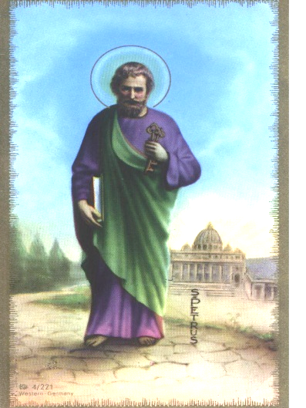PARROQUIA NUESTRA SEÑORA DEL CARMEN

ERMITA SAN PEDRO APOSTOL

LITURGIA PARA EL MES DE_____________________________________

|  |  |  |  |  |  |
| --- | --- | --- | --- | --- | --- |
| **FECHA**  **ACTIVIVIDAD** | **PRIMERA LECTURA** | **SALMO** | **SEGUNDA LECTURA** | **MONICION** | **COLECTORES** |
|  |  |  |  |  |  |
|  |  |  |  |  |  |
|  |  |  |  |  |  |
|  |  |  |  |  |  |
|  |  |  |  |  |  |

**COORDINADORA DE LITURGIA**